Table of Contents

1. Introduction 1

a. Project Introduction 2

b. Justification of Project 2

c. Description of project 3

2. Aims and Objectives 4

3. Development Methodology 4

a. Development Methodology 4

b. Design Pattern 5

c. System Architecture 6

4. Configuration Management 7

5. Prototyping 8

6. Conclusion 11

7. References 12

# 1. Introduction

From recent decades, utilization of cell phones has significantly expanded (around 6 billion till 2018), that has prompted simplicity of completing everyday exercises. Everything daily activities are automated and controlled by mobile phones. Business and money related exchanges would be able to be done effectively and safely, anyplace and whenever. The staggering assignments looked in daily lives can now be accomplished by few of snaps on our smartphones. In this Internet dragged world, any devices almost anywhere can communicate and share necessary information in a click. I want to build up an online stage where people can choose and purchase item on just a click on their phones.

## a. Project Introduction

Conventional shopping is a monotonous and tedious job where Individuals need to surge out to advertise and need to complete their shopping less assortments appeared by retailers. This project manages building up an internet-based business application for online item deal. A web-based business is virtual store on the web where clients can peruse the catalog and select best product of their advantage. The principal motivation behind this task is to build up a universally useful product where clients will find computers, their accessories from the solace of home through web.

## b. Justification of Project

Background of the project

Shopping was an issue till a decade prior. Customers need to crosswise over various market to get the item that they need. With loss of their time, they do need to pay more than the real expense and without comparisons between products which was extremely troublesome. I want to build up an internet business stage where clients will get what they need at reasonable cost. It will assist clients with saving their time with speedier and simpler shopping experience. An online ecommerce with the user-friendly interface ought to be developed that overcomes all the issue faced during physical shopping.

Problem Statements

An ecommerce application gives a straightforward technique to pitch things to a significant customer base. Regardless, there is huge amount of contention among different electronic business goals. Right when Customers touch abase on application, they would like to find what they are hunting down quickly and adequately. Moreover, customers don’t think about the brands or the genuine things they have to purchase. They have a far-reaching thought with respect to what they have to buy. Various customers nowadays check for their things in google rather than visiting express online business regions and they believe it will take them to e-business districts that have their things.

## c. Description of project

This project ought to develop an online ecommerce application that will overcome all the issue faced during physical shopping.

Features of project

* View Catalog

At the point when client visit to application, he/she will most likely view catalog and pick the result of their advantage.

* Register/Login account

Customers will almost certainly make their record in application. It will assist them with getting data about they pick when they lastly visited to site. They additionally can give review about the product they purchased through this application.

* An easy to use checkout

At the point when the client settled the item they need, they will have easy and faster checkout options. Individuals personal account will aid them providing delivery address, payment methods etc. quickest.

* Shopping cart

A shopping basket is incorporated into this site where client can pick the item they need and store product of their choice. At the point of checkout, they can refilter the product of their decision as well.

* An easy search Option

Search bar helps customers to effectively discover the item they need. They can look through the item name or item type in the search bar.

* Easy product comparisons

Utilizing this application, individuals visiting can undoubtedly make examination between items based on quality, cost, features, review etc.

* Product rating

Item evaluating is one of the most powerful feature where clients can see real audit about the item and settle on simple choice weather they should purchase the item or not. They can give feedback in the meantime which will help different client in buying the item.

* Easy User Interface

This application will be easy to utilize and will provide maximum facilities to user with least problems.

# 2. Aims and Objectives

This ecommerce project lifts heap of numerous aims and objective to upgrade shopping nature of individuals.

Aims

The ultimate aim is to build up a web-based application and address the issue looked amid physical shopping.

Objectives

A portion of the principle objectives heap by this project are:

* To design and implement user friendly online business platform/application.
* To build up a broadly useful web-based business where items can be purchased from the solace of home through application.
* To test the application where that satisfies every one of the necessities and recorded prerequisites.
* To improve the proficiency of the application created.
* To give access to latest items accessible from the market.

# 3. Development Methodology

A development methodology is a system that is utilized to structure, plan and control the way toward building up a data framework. Scrum, Lean Development (LD), JAD, RAD, Waterfall, Agile are some of them.

## a. Development Methodology

I lean toward waterfall approach which is the organized advancement process that portrays an advancement strategy that is unbending and linear. I have chosen this on the grounds that each stage has arranged in detail which drives the task being conveyed on schedule and delivered on time. (Anon., 2018)

Waterfall methodology has several phases which are given bellow:

* Planning/system Engineering
* Analysis
* Design
* Development/Implementation
* Maintenance

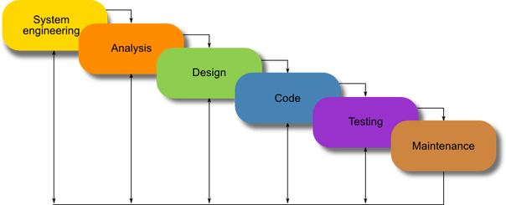

Fig (1) Waterfall model

All the stage from Analysis to Maintenance are done all together. It is hard to return and change something that was not thought of in the concept stage.

## b. Design Pattern

Design pattern is a repeatable solution for usually happing issue in programming structure. It is a format or description for how to take care of an issue that can be utilized in a wide range of circumstances. It can accelerate the development procedure by providing tested, proven development paradigms. Reusing design pattern anticipates unpretentious issues that can cause serious issues and improves code readability for coders and architects familiar with the patterns. (Sourcemaking.com, 2019). Mainly three design patterns are used for android development i.e. MVC (Model-View-Controller), MVP (Model-View-Presenter), MVVP(Model-View-ViewModel).

MVC (Model-View-Controller)

The Model view controller approach separates application at a macro level in three sets of responsibilities.

Model

Model is the data + state +Business logic for our application. It is the central part of application were business logic is defined called as brain of application. It isn’t attached to view or controller, and it is reusable in numerous unique circumstances.

View

View is the representation of the model and has a duty to render the user interface and convey to controller when the client interacts with application. It defines the user interacting part where it only conveys information from controller to user and vice versa.

Controller

Controller acts as glue that integrates the application and is the master controller for what happen in the application. At the point when the view tells the controller that a client clicked a button, the controller decides how to interact with the model accordingly.

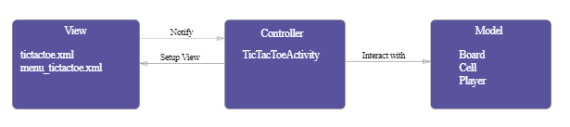

Fig (3) MVC pattern

## c. System Architecture

A lot of individuals underestimate the significance of system architecture. When you are planning to build a system, a good architecture is foundation of the system. It is the blue print of both system and project which is primary carrier of system qualities such as scalability and performance.

i. Three Tire Architecture

A three-tier architecture is a client-server architecture in which the functional process logic, data access, computer data stockpiling and UI are created and kept up as independent modules on independent stages/platforms. It permits any of the three levels to be updated or supplanted autonomously. The user interface is implemented uses a standard graphical user interface with different modules running on the application server. The RDBMS on the database server contains all the data storage logic and the center level tiers are usually multitiered.

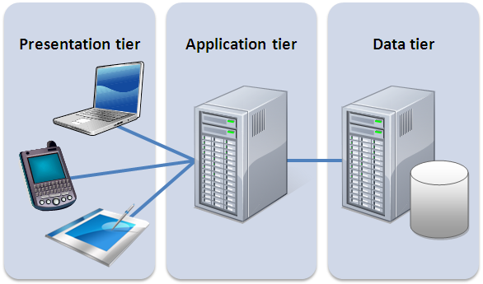

Fig(2): Three tier architecture

Presentation tier

Occupies the top dimension and shows data identified with administrations accessible on a site or application. It communicates with other tiers by sending results to the browser and other tiers in the network.

Application tier

Central level, logic tier or business tier controls applications functionality by performing definite processing.

Data Tier

Houses database servers where data is stored and retrieved and data in this tier is kept independent of application server or business logic.

# 4. Configuration Management

Configuration management is a practice of handling changes methodically/systematically so a framework keeps up its integrity over time. The procedure guarantees that the deliverable meets the predefined execution criteria. It additionally guarantees that sufficient procedure is set up to provide continuing support for the duration of the product life cycle. Mostly now a days, GitHub (an online tool) is used to maintain integrity in application. The service includes access controls as well as a number of collaboration features like tools for task management and for all activities you handle. It infers the version control framework which enables developer to monitor the consistent amendments to their code.

Project GitHub link: <https://github.com/aryalaashish121/online-store.git>

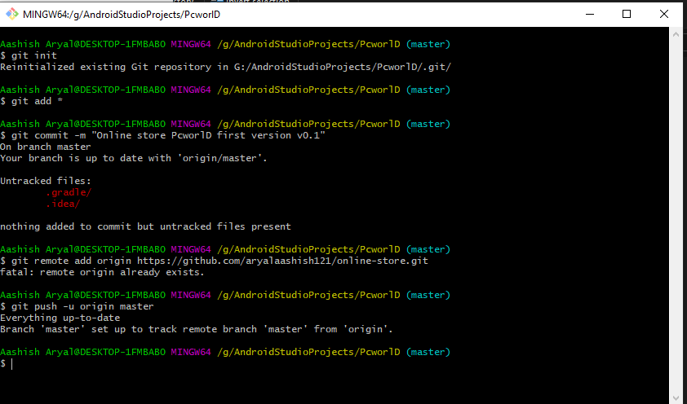

Fig (4) Sample GitHub upload

# 5. Prototyping

Prototyping isn’t for every project, but for the project it is right for, it can be a tremendous asset. It has numerous advantages over a time. It improves the quality specifications and requirements provide to customers. It ensures product quality and savings for years to come. I have used online tool *Figma* for prototyping some basic user interfaces.

i. Home/Initial Page

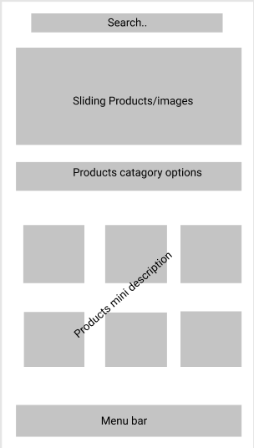

Fig (5) Home page

ii. Registration page

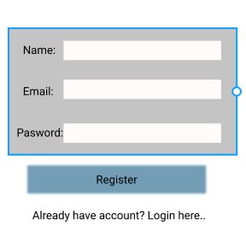

Fig (6) Registration page

iii. Login page

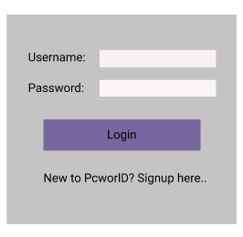

Fig (7) Login Page

iv. Product page respect to description

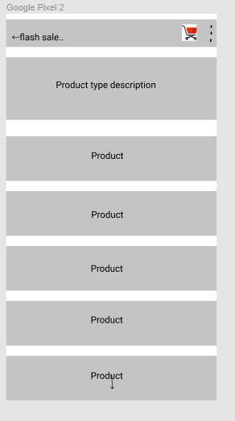

Fig (8) Product page

# 6. Conclusion

In this venture, a site will be created which will change all the shopping background from physical to virtual reality where individuals can without much of a stretch access a large number of items from the solace of their home. User interface prototyping is already done which ensures the project completes on time.

# 7. References

Sourcemaking.com. (2019). Design Patterns and Refactoring. [online]

Available at: https://sourcemaking.com/design_patterns [Accessed 12 Apr. 2019].

Anon., 2018. IT knowledge portal. [Online]   
Available at: http://www.itinfo.am/eng/software-development-methodologies/  
[Accessed 2 July 2018].

Anon., 2018. utest. [Online]   
Available at: https://www.utest.com/articles/why-is-software-testing-necessary  
[Accessed 5 July 2018].